TITLE: Routing in the Internet

Name: Janhavi Gattani
Division: A
Batch: 03
Roll Number: 37
PRN: 12311291

Experiment Number: 02

Experiment Title: Routing in the Internet

Aim and Objective:
Write a program to find the shortest path using Dijkstra Equation for Link State Routing Protocol which is used by Open Shortest Path First Protocol (OSPF) on the Internet for the network flow provided by the instructor.

Theory:
Overview of Dijkstra's Algorithm:
Dijkstra's algorithm is a graph search algorithm that efficiently finds the shortest path from a source node to all other nodes in a weighted graph. It starts by initializing distances to all nodes as infinity, except for the source node, which is set to zero. Then, it iteratively selects the node with the smallest distance from the source and updates the distances to its neighbouring nodes. The process continues until all nodes have been visited.
Steps to Find the Shortest Path:
- Initialization: Initialize a distance vector for each node, setting the distance to the source node as zero and all other distances as infinity. Also, maintain a set of unvisited nodes.
- Selecting the Nearest Node: At each iteration, select the node with the smallest distance from the source node among the unvisited nodes.
- Updating Distances: For the selected node, update the distances to its neighboring nodes if the distance through the selected node is shorter than the current distance. This involves comparing the sum of the distance to the selected node and the distance from the selected node to its neighbor with the current distance to the neighbor.
- Marking Visited Nodes: Mark the selected node as visited and remove it from the set of unvisited nodes.
- Repeat: Repeat steps 2 to 4 until all nodes have been visited.
- Shortest Path Tree: Once the algorithm is complete, a shortest path tree is constructed, with the source node as the root and edges representing the shortest paths to each node.
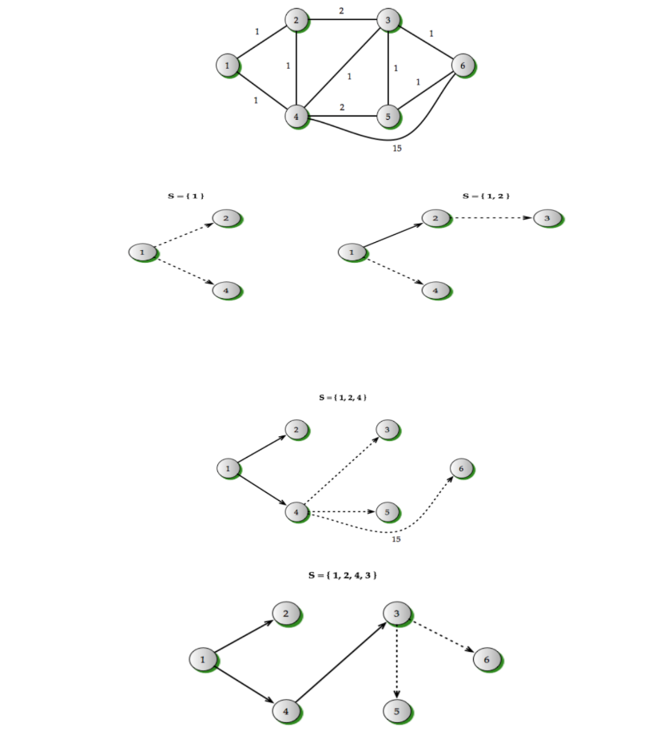
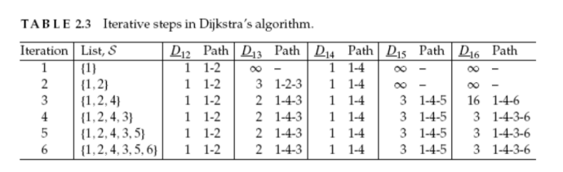

Application in Link State Routing Protocol:
In Link State Routing Protocol, each router exchanges information about its directly connected links with other routers in the network. This information includes the link cost or distance. Using this information, Dijkstra's algorithm is applied at each router to compute the shortest path to all other routers in the network.

Code:
#include <iostream>
#define INF 9999
#define MAX 100

using namespace std;

int main() {
int graph[MAX][MAX], nodes, edges, src;

cout << "Enter number of nodes: ";
cin >> nodes;

for (int i = 0; i < nodes; i++) {
for (int j = 0; j < nodes; j++) {
if (i == j)
graph[i][j] = 0;
else
graph[i][j] = INF;
}
}

cout << "Enter number of edges: ";
cin >> edges;

cout << "Enter edges in format: from to weight (0-based index)\n";
for (int i = 0; i < edges; i++) {
int u, v, w;
cin >> u >> v >> w;
graph[u][v] = w;
graph[v][u] = w;
}

cout << "Enter source node (0 to " << nodes - 1 << "): ";
cin >> src;

int dist[MAX];
bool visited[MAX];

for (int i = 0; i < nodes; i++) {
dist[i] = INF;
visited[i] = false;
}

dist[src] = 0;

for (int count = 0; count < nodes - 1; count++) {
int min = INF, u;

for (int i = 0; i < nodes; i++) {
if (!visited[i] && dist[i] <= min) {
min = dist[i];
u = i;
}
}

visited[u] = true;

for (int v = 0; v < nodes; v++) {
if (!visited[v] && graph[u][v] != INF &&
dist[u] + graph[u][v] < dist[v]) {
dist[v] = dist[u] + graph[u][v];
}
}
}

cout << "\nShortest distances from source node " << src << ":\n";
for (int i = 0; i < nodes; i++) {
cout << "To node " << i << " = " << dist[i] << endl;
}

return 0;
}

OUTPUT:
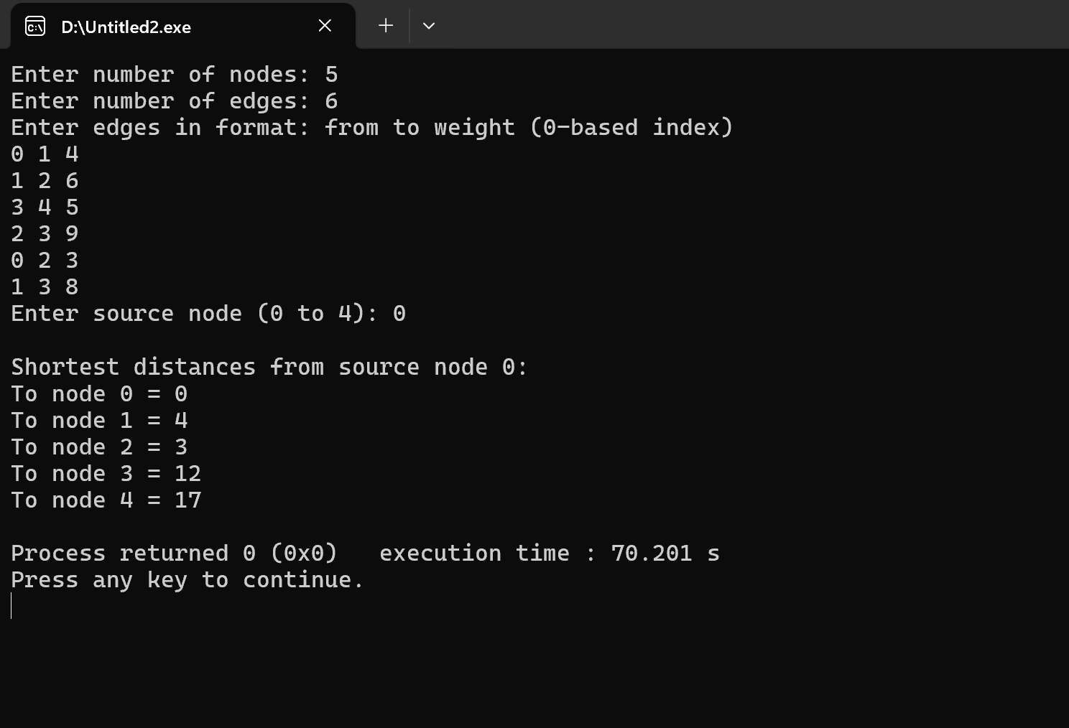

FLOWCHART:
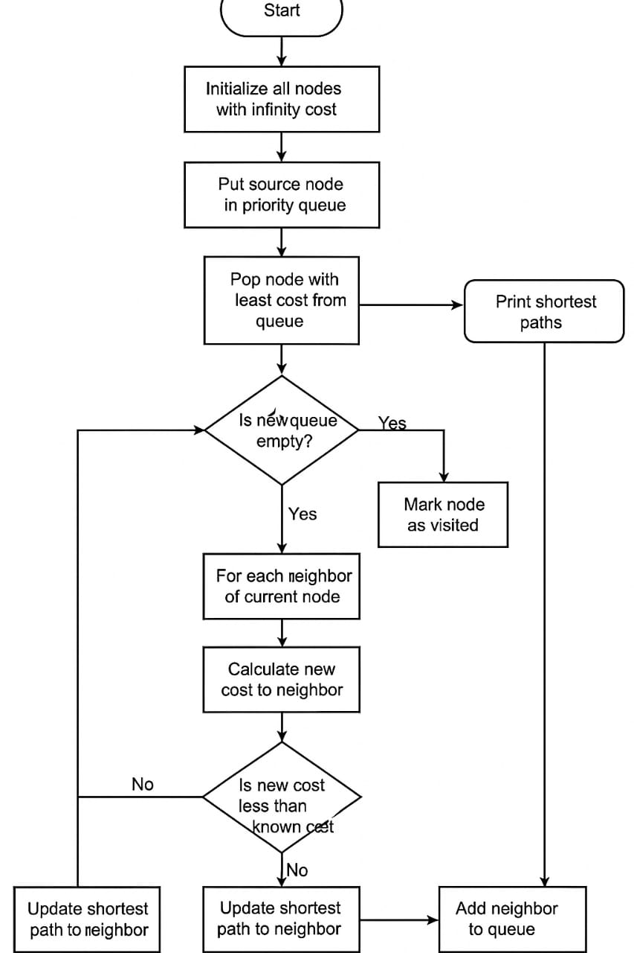

Conclusion:
Dijkstra's algorithm plays a crucial role in the Link State Routing Protocol by enabling routers to compute the shortest paths efficiently. By maintaining a database of network topology information and applying Dijkstra's algorithm, routers can make informed routing decisions, leading to efficient and reliable communication within the network.

